Questionsheet

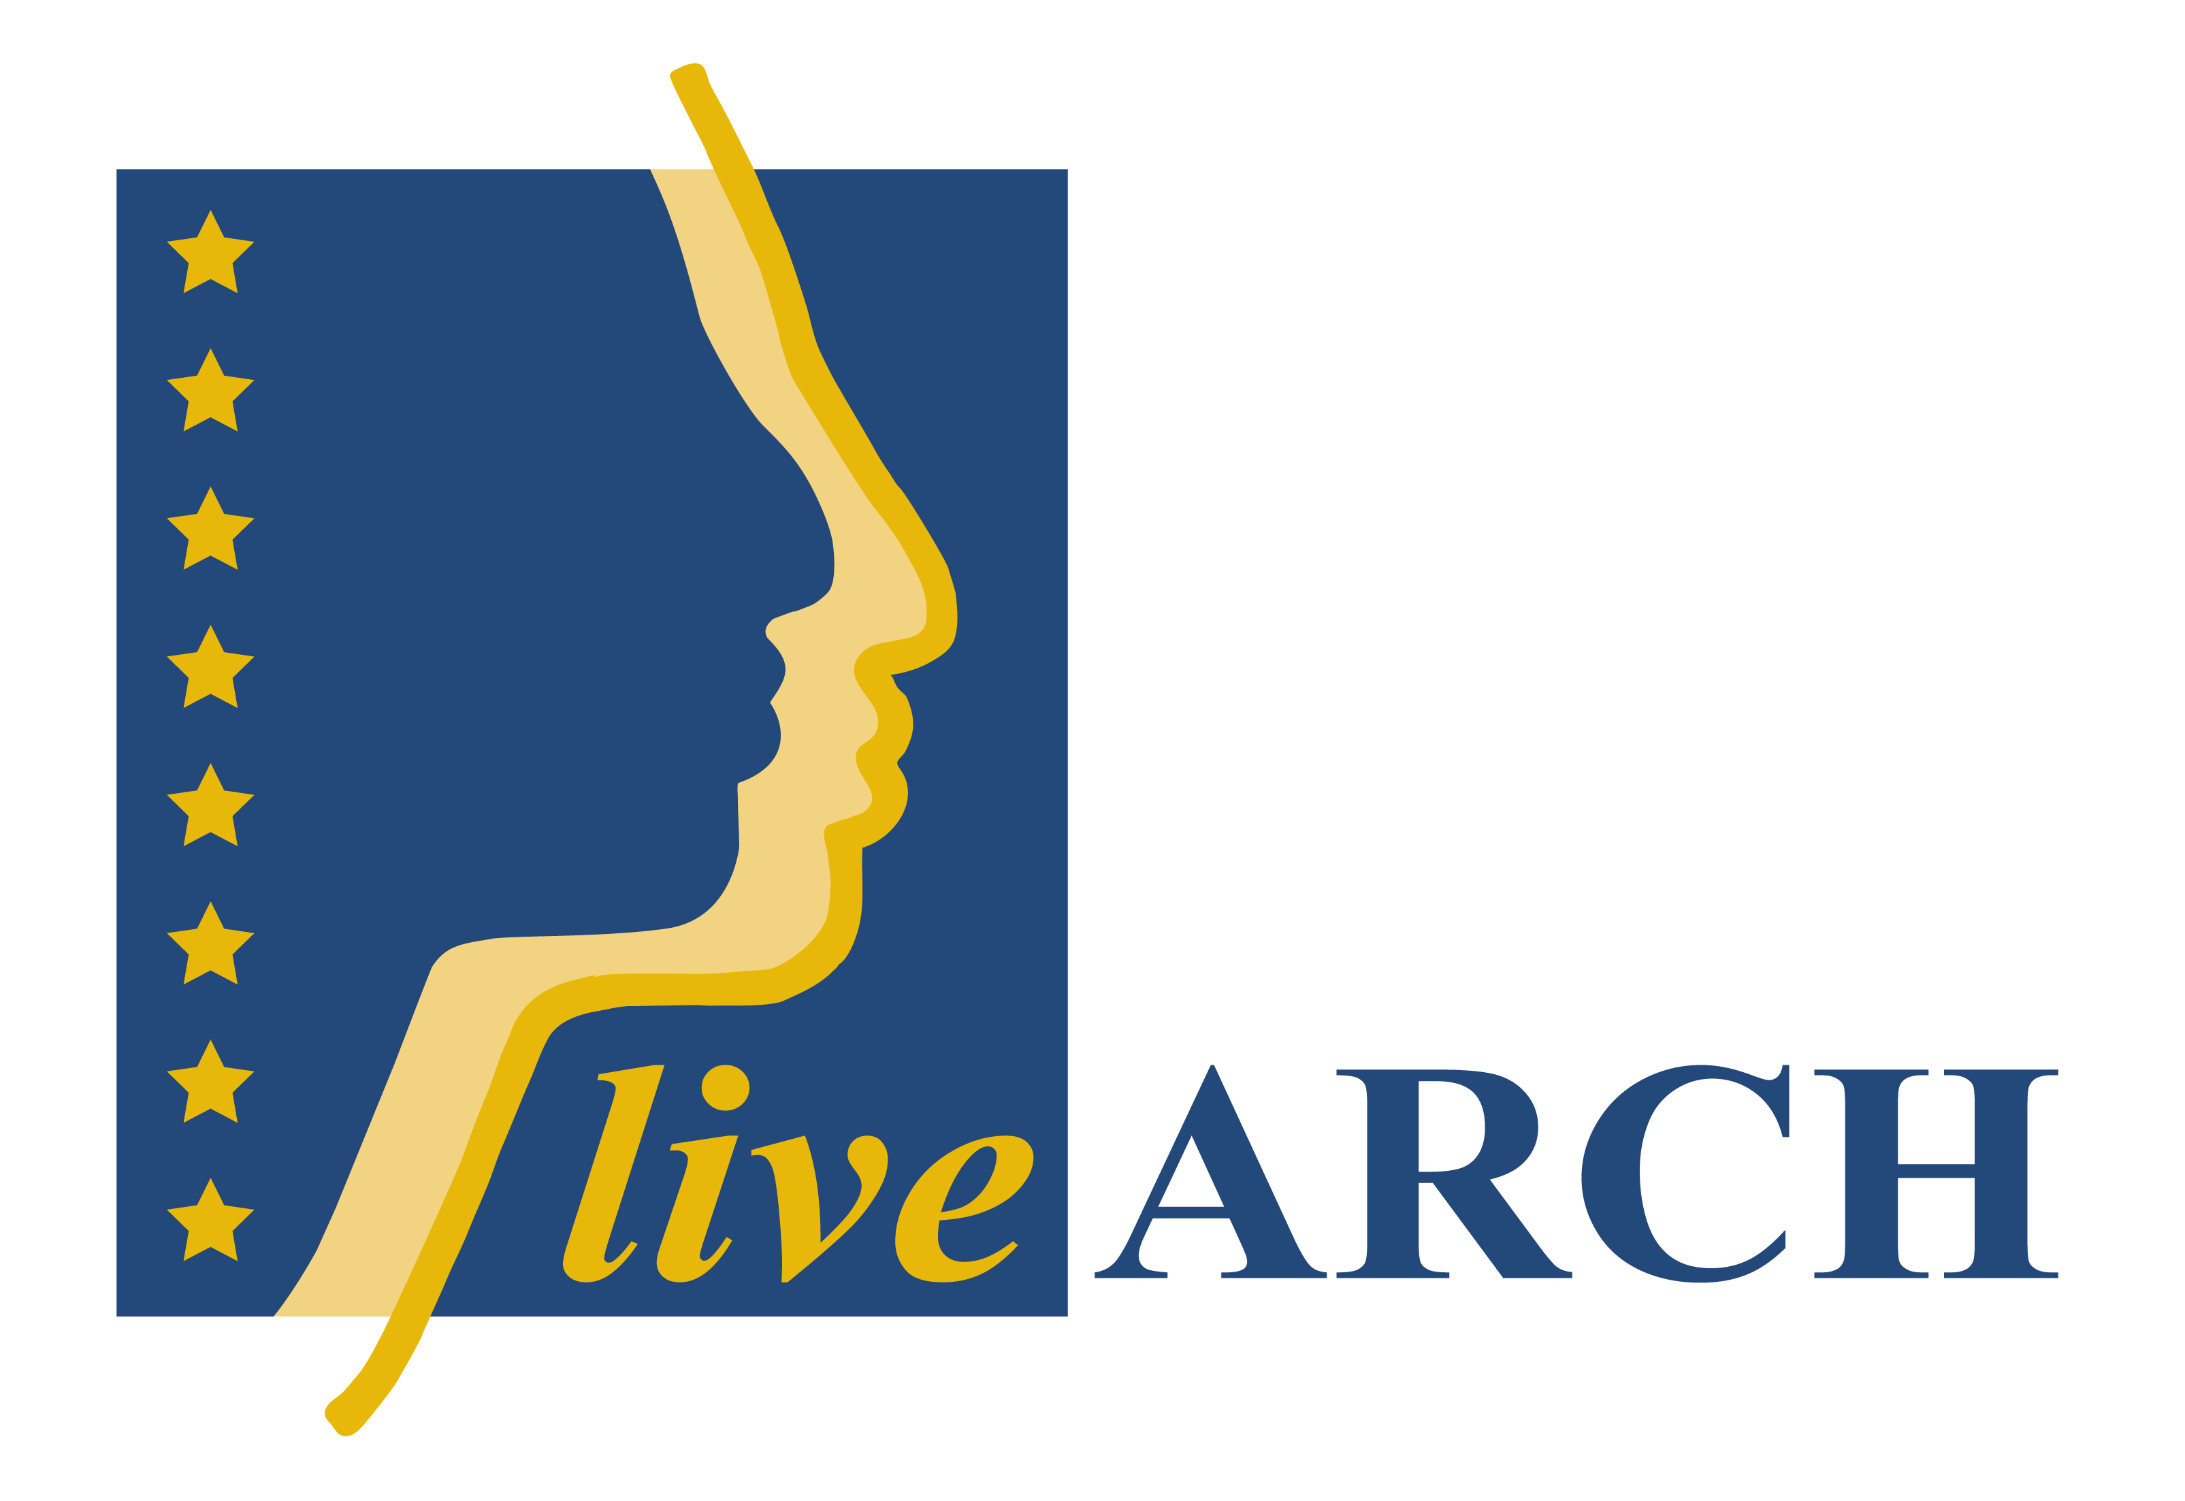

QUESTIONS CHAPTER 2:

Question 1: What kind of mediation types that IMTAL uses do you practice at your museum?

Question 2: What kind of mediation types that IMTAL uses don’t you practice at your museum?

Question 3: Why do they not fit your organisation?

Question 4: Do you mix 1st and 3rd person interpretation? If so please describe how?

Question 5: We do not use neither 1st person interpretation nor 3rd person interpretation. Instead we use:

Question 6: Is didactics of great importance in your organisation? Please describe further.

QUESTIONS CHAPTER 3:
Question 7: Do you work as an Archaeological Experimental Centre or location– for science?

Question 8: Do you work as an Archaeological Experimental Centre or location– for education?

Question 9: Do you work as a resource for AOAM as a person or as a group?

Question 10: Are you a Project that will become AOAM?

Question 11: Are you a Re-enactment site not intended for visitors?

Question 12: Are you a site without reconstructed buildings?

Question 13: Are you a Visitor Centre – not a museum?

Question 14: Are you a commercial Theme Park?

QUESTIONS CHAPTER 4:
Stämmer dessa påståenden överens med er museala verksamhet? Ja/Nej
Om nej beskriv varför.

Question 15:

A Museum
“A museum is a non-profit4, permanent institution in the service of society and its development, open to the public, which acquires, conserves, researches, communicates and exhibits the tangible and intangible heritage of humanity and its environment for the purposes of education, study and enjoyment.” (ICOM Statutes, approved in Vienna (Austria) – August 24, 2007. Art. 3, Section 1).
Professional practice and performance in Archaeological Open Air Museums should respect the ICOM Code of Ethics for Museums (ICOM 2006, www.icom.museum).

Question 16:
B Archaeological
“Archaeological data are the primary source of information of what is reconstructed and interpreted.”

Question 17:
C True-to-scale architectural reconstructions in the open air
Archaeological Open Air Museums deal with outdoor true-to-scale reconstructed buildings. These can be constructed and interpreted only under the condition that: “the original buildings of the type portrayed are no longer available (and) the copies or reconstructions are made according to the strictest scientific methods” (ICOM declaration: 9th July 1956/1957 Geneva, section 6).
The authenticity of materials and techniques used should be clearly accounted for through written and accessible records, quoting the sources of information on which the reconstructions are based. An honest assessment of each reconstruction should be feasible.

Question 18:
D Collections of intangible heritage resources

The overall presentation of an Archaeological Open Air Museum holds collections of intangible heritage resources and provides an interpretation of how people lived and acted with reference to a specific context of time and place.

Question 19:
E Connected to scientific research
The connection between scientific research and any specific Archaeological Open Air Museum is provided by the active role of a trained archaeologist among the staff or an archaeological counsellor belonging to an affiliated organisation.

Question 20:
F Appropriate interpretation with organisation of activities for visitors
Depending on the nature and number of visitors, different kinds of interpretation can be appropriate. These activities can involve (but are not limited to) guided tours, educational programmes, presentation of experimental archaeology research, demonstrations of ancient crafts and techniques, live interpretation and living history activities.

Svara på påståendena under rubriken “Registered museums must have competence in several areas:” med ett ja eller ett nej. Om ni svarar nej beskriv varför.

Svara på påståendena nedan med ett ja eller nej. Om nej beskriv varför.

Your institution is/has:

Question 21:
- Not-for profit (a surplus has to be used only for the museum’s needs).

Question 22:
- Open to the public at least 800 hours per year

Question 23:
- A minimum of one person employed full-time all year round or contracted.

Question 24:
- In the service of society and for its development (no primarily commercial interests).

Question 25:
Fulfilling the aims

Question 26:
- Reconstructions built with a high authenticity of material and
techniques?

Fotevikens svar: Ja.

Question 27:
- Working with experimental archaeology

Question 28:
- Interpreting experimental archaeology?

Please comment on the statements below with yes or no. If no, please describe why.

Question 29:
The presentation should demonstrate a complex context.

Question 30:
The presentation should reach different ages and classes in society.
Question 31:
The presentation should be up to date, informative, and educationally useful. Communication with the visitor should work with pedagogically- based programmes and should educate as well as entertain.

Question 32:
There must be a scientific director or at least a committee of prehistorians guiding the museum.

Question 33:
There should be quality management.

Question 34:
Archaeological Open Air Museums are using reconstruction based on experimental archaeology and interpretation of archaeological artefacts and historical sources.

Question 35:
Do you have a clear statement of aims and objectives for your museum?

Question 36:
Do you have tasks to achieve objectives for your museum?

Question 37:
Do you have a programme of tasks for the museum?

Question 38:
Do you have monitoring points within the programme for your museum?

QUESTIONS CHAPTER 5:A

Svara på dessa frågor med ett ja eller ett nej. Om ni svarar nej beskriv varför.

Question 39:
Are your reconstructions made for public mediation and are interpretations of them based on trial and interpretations of archaeological theory?

Question 40:
Are the reconstructed tools, clothing and buildings the results of experimental archaeology, and an interpretation of the archaeological material, and the scientific knowledge accumulated?

Question 41:
Has the reconstruction undergone a planning stage, where musicological criteria, the suitability and cost aspects has been taken into consideration?

Question 42:
Have criteria’s, such as security, safety, quality, economy and sustainability been taken under consideration?

Please comment the following statements about what you been using when you have made your reconstruction and if there is something you have not been using please explain why.

To reconstruct a historical environment, these different variables are used:

Question 43:
Preserved artefacts, plants, macro-remains, animal bones, wood etc.

Question 44:
Preserved written sources, which describe environments of that time.

Question 45:
Different physical features being geographically conditioned.

Question 46:
Historical, national, economic conditions

Question 47:
Common human logic, human functional behaviour and creativity

QUESTIONS CHAPTER 5:B

Question 49:
Are your reconstruction an experimental project and has therefore become an untouchable monument today or from the very beginning? Are you today using it for live interpretation?

Question 50:
Have you changed the monument to be used for the public, taking into consideration matters like: disabled people, maintenance, security?

Question 51:
Have you altered it for live interpretation with furnishing and re-enactors?

If your reconstructed building or tools not from the beginning are an experimental reconstruction but the reconstruction and the tools from the very beginning are for the museums visitors where the consideration for disabled people, maintenance, security and live interpretation has been planned for, do you then have (please answer the following questions with yes or no):

Question 52:
Made ground work taking in consideration the draining of the ground to lower the wetness of the building and the maintenance cost?

Question 53:
Do you have the doors made wider and special paths for wheelchairs?

Question 54:
Have you used hidden modern material in the roof, floor, fundament or walls? If yes, please explain what, how and why.

Question 55:
If yes on the question above, please describe how you have implemented and made it invisible without disturbing the live mediation of the building.

Question 56:
Have you as a part of making the reconstruction for the public been using ancient tools to prove that it can have been done this way?

Question 57:
Can the public take part and see how and which historical tools you have been using in the reconstruction?

Question 58:
Do you use empty houses or do you use houses with interiors?

Question 59:
Do you use puppets? If your answer is yes, please describe how and where.

Question 60:
Do you use interactive puppets? If your answer is yes, please describe how and where.

Question 61:
Do you use dressed up re-enactors or people dressed in modern clothes?

Question 62:
Do you use guides?

Question 63:
Do you use re-enactors?

Question 64:
If you use guides, are they dressed in historical clothes or in modern clothing?

Question 65:
Do other personnel wear historical clothes? Please answer the following questions with yes or no:

- Staff at the entrance:

- Staff in the museum shop:

- Office staff:

- Staff in the restaurant:

- Other personnel? Please state which:

Question 66:
Do you use audio guide?

Question 67:
Do you have an entrance where the visitor could get background information to the historical contex in which they shall enter? If yes, please describe in which way you mediate this context.

Question 68:
Do you use leaflets so that the visitors can orientated themselves and get deeper knowledge from what they se?

Question 69:
Do you use this together with the guide or not?

Question 70:
Do you use other published material in order to öka interaktiviteten på plats? Om ja, beskriv vad.

Question 71:
Do you use tryck/digitalt material för förarbete innan besök?

Question 72:
Do you use tryckt material för efterarbete på annan ort?

Question 73:
Do you use signboards?

Question 74:
Are the signboards attached directly to the reconstruction? Or is it put on a post hole in front of the reconstruction? Are you using the signboards in another way, please describe.

Question 75:
Do you mix signboards with re-enactors or/and guides dressed up in historical clothing? If you do, please explain why.

Question 76:
Are you aware that dramaturgigly (hur stavas detta??) this gives a bad and interference communication with the visitor and should not be used?

How do you cope with the possibility for visitors to enter the houses and be able to experience hands on (please answer the following questions):

Question 77:
Do you have any fences like rope, glass etc to distance the public from the environment? If yes, please explain why?

Question 78:
Do you use artificial light in the reconstruction? If yes,

- Are they visible modern lights?
- Are they hidden indirect light?
- Are they implemented light like electrical candles, face fire etc?
Please describe what you are using and why and also why you not are only using daylight and fireplaces and “candles”.

Question 79:
Are you using other modern equipment that can be hidden? If so do you try to hide it? If not why?

Question 80:
Describe how you work with mediation (schools/tourists). Do you use:

Interactive media? If yes, please describe what:

Iphone?

Recorded/live sound in order to heighten the background effect? If your answer is yes, please describe what.

Speaker in loudspeaker (for example during guidance)?

Interactive buttons? If yes, please describe in what context.

Movie integrated in the historical environments? If yes, please describe where and why.

QUESTIONS CHAPTER 6

Question 81:
Do you have a dialogue with the visitors so you can be able to analyse and improve the AOAM´s mediation?

Make a SWOT analyse to check the visitors surveys (skall alla AOAMs använda sig utav en och samma eller kan varje museum använda sig utav sina egna? Detta bör nog stå i så fall. ) and other input to get you started in a process to improve your dialogue with the visitors.

Strengths
Weaknesses
Opportunities (beyond your control)
Treats (beyond you control)

Strengths | Weaknesses
Opportunities (beyond your control) | Treats (beyond you control)

QUESTIONS CHAPTER 7

Question 82:
Do you have a dialogue with science at Universities and experimental archaeologists so you can be able to improve the AOAM´s knowledge and scientific level?

Make a SWOT analyse to check the dialogue with science at Universities and experimental archaeologists to get you started in a process to improve your knowledge and scientific level.

Strengths | Weaknesses
Opportunities (beyond your control) | Treats (beyond you control)

Question 83:
Do you have a collection? Yes or no.

Question 84:
If yes: is your collection tangible and are you following the ICOM rules?

Question 85:
Do you have an intangible collection?

Question 86:
How do you document, register and store your intangible collection?

Question 87:
Do you have a collection of experimental projects and equipment?

Question 88:
Do you have a documentation of your experimental projects and equipment?

Question 89:
Do you have a collection of re-constructions?

Question 90:
Do you have a documentation of what your tangible artefacts, intangible tools (?), experimental project and equipment your reconstructions is based on.

Question 91:
Do you have guidelines for how to operate the intangible culture heritage in your area?

QUESTIONS CHAPTER 8

In an AOAM there are a number of activities that are related to ancient crafts:

Question 93:
What resources do you have to base the skills, knowledge and education for making the reconstruction?

Question 94:
How does your museum cope with the high level of authenticity?

Question 95:
Do you have a plan for the scientific level of the skill and handcraft?

Question 96:
How do you follow the object of reconstruction corresponds to the archaeological evidence to get the results of the academic research?

Question 97:
How do you provide the knowledge based on the scientific research of archaeological data available and the knowledge provide by archaeological experiment – to make it authentic?

Question 98:
How you achieve the accuracy by using the practical skills in creation of the presentations of the ancient history if it should be as close as possible to ancient contexts?

Question 99:
Do you use necessary knowledge for sustainable reconstructions?

Question 100:
How do you make you reconstruction appropriated?

Question 101:
How are you financing you reconstructions?

QUESTIONS CHAPTER 9

Question 102:
Do you have a marketing plan for the next year? If not, please make one using appendix 5.

Question 103: a
Do you have a marketing budget for next year?

Question 104:
Do your logo and colour code match your profile?

Question 105:
Do you use it every time when there is a something associated with you?

Question 106:
What is your profile (describe in one sentence):

Question 107:
What is your Image (describe)

Question 108:
Does your image match your profile?

Question 109:
If not what doesn’t match (describe)

Question 110:
Can you work with the things that doesn’t match your profile and change people how they thing about you?

Question 111:
If you can, how:

Question 112:
If not, can you change your profile into another direction so the peoples image can change?

Question 113:
Do you have a slogan, if you do write it down ( if it’s in your mother tongues translate it to English)?

Question 114:
If yes, does it match your profile?

Question 115:
Do you have a profile package? (Vector-logo, CMYK-profile, slogan)

Question 116:
Does your marketing plan state what segmenting of visitors is your best target group?

Question 117:
What is your target group?

Question 118:
Does your marketing plan state what medium is best used for you?

Question 119:
What medium does your marketing plan state?

Question 120:
Do you stick to your marketing plan?

Question 121:
If no explain why:

Question 122:
Do your marketing plan state how you can attain statistics regarding to the use of different media?

Question 123:
Do you attain visitor statistics so you can match it towards the target group in your marketing plan?

QUESTIONS CHAPTER 10
Question 124:
Make an analyse of who you are compared with your customers including your mission and vision:

Question 125:
Make a developmentplan with steps and goals for your museum (short and long term goals):

Question 126:
Do you have a plan for running and maintaining the environment, the service facilities and reconstructions? Yes or NO?

Question 127:
If no, please make one:

Question 128:
Have you separated your organisation and business into different operational areas?

Question 129:
Do you have a staff management plan which also include a sustainable and stress friendly environment, if not make one?

Question 130:
Do you have a plan for, if not make one:
- Work duties easy to interpret
- A well- planned operational policy
- How to handle full-time and temporary staff in different seasons.
- Staff training plan
- Salary policy
- Control document for managing the different concepts

Question 131:
Do you at least have one person that can be contacted all year around at your AOAM?

Question 132:

Are you:
Open to the public YES/NO?

Do you have:
- Controlled entrance YES/NO?

- Parking space YES/NO?

- Shop YES/NO?

- Restaurant or cafeteria YES/NO?

- Toilets YES/NO?

- Child care YES/NO?

Question 133:
Do you have:

- Annual budget Yes/No?

- Earning generators Yes/No?

- Donors and sponsors Yes/No?

- Applying for funds Yes/No?

- A friends’ association Yes/No?

- Relations with the press Yes/No?

Question 134:
Do you have a maintenance schedule for a daily, weekly and monthly basis in your organization plan?

Question 135:
Do you have relations with a organizations representing the handicapped so the goals for accessibility is met?

Question 136:
Do you have a Safety plan?

Question 137:
Do you have an environment plan? If not, please make one.

